 **CP2406 Programming-II: Practical-1**

This document has been prepared by Dr. Dmitry Konovalov for James Cook University. Updated 3 August 2017.

**© Copyright 2015**

This publication is copyright. Apart from any fair dealing for the purpose of private study, research, criticism, or review as permitted under the Copyright Act, no part may be reproduced by any process or placed in computer memory without written permission.

**Instructions for on-campus version:**

* **WHEN**: Teaching week #2 at JCU; Teaching week #1 at JCUS/JCUB (scheduled after lectures)
* **DURATION**: two hours
* **ATTENDANCE**: compulsory (students must attend). You (student) ***must sign/initial the attendance sheet*** provided by your instructor.
* **MARKING [1 mark]**: Complete the tasks from this practical and show the completed tasks to your instructor. Each completed practical is awarded **ONE participation mark** towards the participation assessment component of this subject.
* **EARLY SUBMISSIONS**: You are encouraged to attempt (and complete) some or all of the following tasks ***before*** attending the practical session.
* **LATE SUBMISSIONS**: You may finish the following tasks in your own time and then show your completed tasks during the following week practical. **The main intent here is to encourage you as much as possible to complete all practicals**. ***If you are late by more than one week***, you will need a valid reason for your instructor to be awarded the marks.

**Instructions for off-campus/online version**

* WHEN: Teaching week #2 at JCU; Teaching week #1 at JCUS/JCUB (scheduled after lectures)
* DURATION: two hours
* ATTENDANCE: compulsory (students must attend). You (student) ***must sign/initial the attendance sheet*** provided by your instructor.
* MARKING: Complete the tasks from this practical and show the completed tasks to your instructor.

**TASK-1: Java Editor: IntelliJ IDEA [15-30 min]**



* JetBrains offers free access for JCU students to the **Ultimate** Edition of Intellij IDEA. Signup here: <https://www.jetbrains.com/student/> using your JCU email address.
* Alternatively, you could use the **Community** Edition. To install it on your personal computer, go to <https://www.jetbrains.com/idea/download/> and download (and then install) the **Community** Edition.
* Locate the installed IntelliJ program on your personal or university computer and launch it.
* *NOTE: Software and websites are regularly updated. If any of the links are broken or referred to an older version of IntelliJ, please Google “hello world in IntelliJ tutorial”.*
* Watch the first two Getting-Started tutorials from <https://www.jetbrains.com/idea/documentation/> :
  + 1) Running-IntelliJ-for-the-first-time tutorial <https://www.youtube.com/watch?v=L_jXj0XTwSg>
  + 2) Finding your way around IntelliJ <https://www.youtube.com/watch?v=X49xqVDR8VQ>
* Work your way through the help document on how to create and run your first java program: <https://www.jetbrains.com/help/idea/creating-running-and-packaging-your-first-java-application.html>
* Show your “hello world” program running to your instructor to be marked off for this task.

**TASK-2: GitHub [15-30 min]**

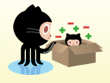

* In this subject we will be using GitHub for all source code management.
* Sign-in (or sign-up) to g <https://github.com/>
* NOTE: All github repositories are public by default. You need to apply for private repositories as a student (if you have not done so already), see <https://education.github.com/guide/private_repos> .
* Work your way through the help document on how to connect your IntelliJ to your GitHub account: <https://www.jetbrains.com/help/idea/using-git-integration.html>
* You should have some knowledge about git-repositories from other subjects (e.g. CP1404-Programming-1). If however, you feel you may need a re-fresher, please work through the github-hello-world tutorial, see <https://guides.github.com/activities/hello-world/> .

**TASK-3: Connecting Github and IntelliJ [15-30 min]**

* Sign-in (see task-1 above) to your github account and then click <https://github.com/CP2406Programming2/cp2406_farrell8_ch01> repository.
* **Working with GitHub:** You need to make a copy of this repository so you could modify it. This is done by clicking “Fork” (in the upper left corner of the repository page)  
  + 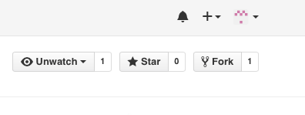
  + For more help with “forking”/copying, see <https://guides.github.com/activities/forking/> (or google “how to fork on github”)
  + NOTE: You do no need to make “Pull-requests”. All repos in these subject practicals are for distribution purpose. That is, you do not want your solution source code to be “pulled” into the master copy.
* **Connecting IntelliJ:** Now you should have your own copy (repo) of the source code for this task. ***Please read carefully now!*** It may be confusing, but what you want to end up with is your solution to be ***saved into your github account***.
  + Relevant IntelliJ help page is <https://www.jetbrains.com/help/idea/using-git-integration.html>
  + Start IntelliJ; Select “Check out from Version Control”, and “GitHub”
  + 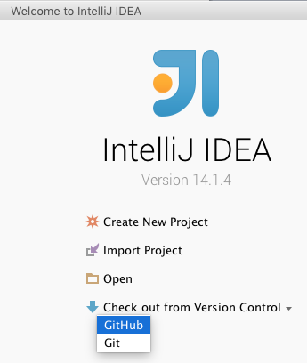
  + If you already have IntelliJ running, go to the Menu and select File:ProjectFromVersionControl:GitHub

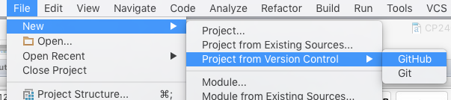

* + You will be presented with a few steps, where you must enter ***your github login details***.
  + Once IntelliJ connected you to your github account, you should be able to select today’s prac. Select and click “Clone”.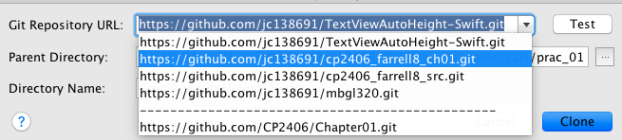
  + If you do not see “cp2408_farrell8_ch01.git”, then you did not forked/cloned the master repo from <https://github.com/CP2406Programming2/cp2406_farrell8_ch01> . Go back to the beginning of this Task-3 and try again.
  + IntelliJ will present you with the new-project-wizard pages. Accept all defaults and you should end up with something like this:

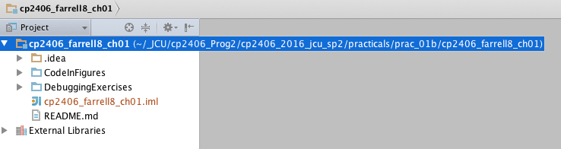

**TASK-4: Chapter-1 Debugging Exercises [15-30 min]**

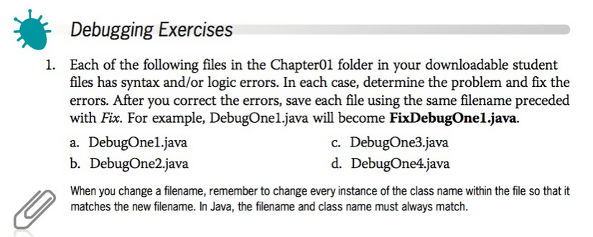

* The above description of the debugging exercises is from the textbook.
* Try to build (aka “Make Project”) your chapter-1 project:  
  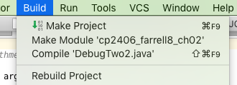
* If needed, see <https://www.jetbrains.com/help/idea/creating-running-and-packaging-your-first-java-application.html> on how to do this.
* IntelliJ will display ***compiling*** errors. Work your way through all of them until all compiling errors are fixed. See the following Figure for help:
* 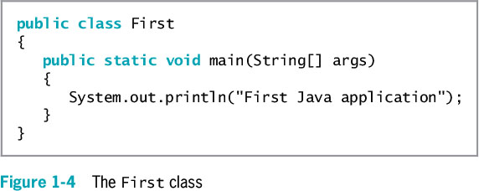
* Commit (see <https://www.jetbrains.com/idea/help/committing-changes-to-a-local-git-repository.html> ) and then push (see <https://www.jetbrains.com/idea/help/pushing-changes-to-the-upstream-git-push.html> ) your solution back to your github account.
* If you do not wish to read the help links above, here is an easy way to commit and push the whole project. Right-click on the project name and select Git:CommitDirectory…

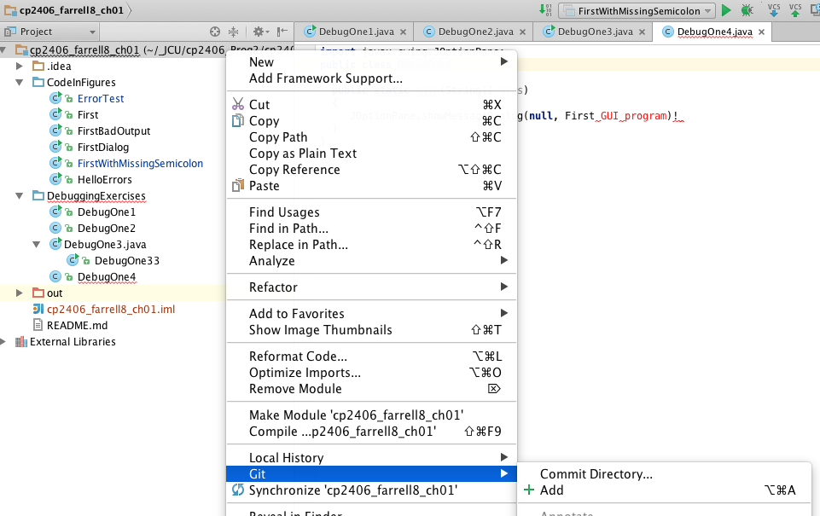

Then Commit and Push in one go (The button “Commit” turns into sub-buttons):

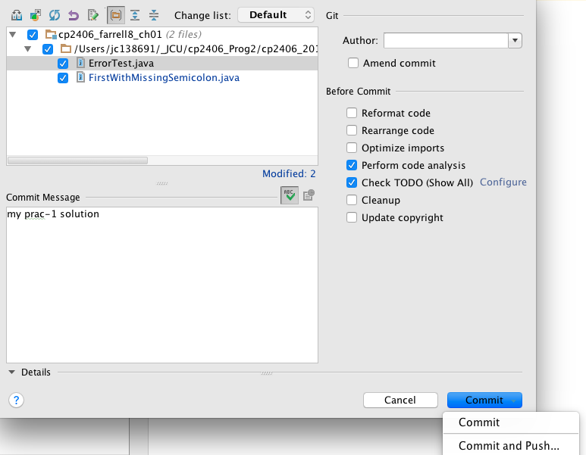

**TASK-5: Chapter-1 Programming Exercises [10-20 min]**

* Complete any ***two*** exercises from the following list, ***or as directed by your instructor***.
* **Learning tip:** Try complete more exercises to learn and practice programming skills. ***Programming is a contact sport!*** You do not become a better programmer by watching others.
* First try to complete the exercises without looking in the textbook (google for Java classes if needed).
* If you need more help, look through the chaper-1 textbook, source code and/or debugging code, <https://github.com/CP2406Programming2/cp2406_farrell8_ch01> (or your own fork).
* If you are still struggling, pick at the solutions, <https://github.com/CP2406Programming2/cp2306_farrell8_prac_solutions/tree/master/Chapter01/ProgrammingExercises> .

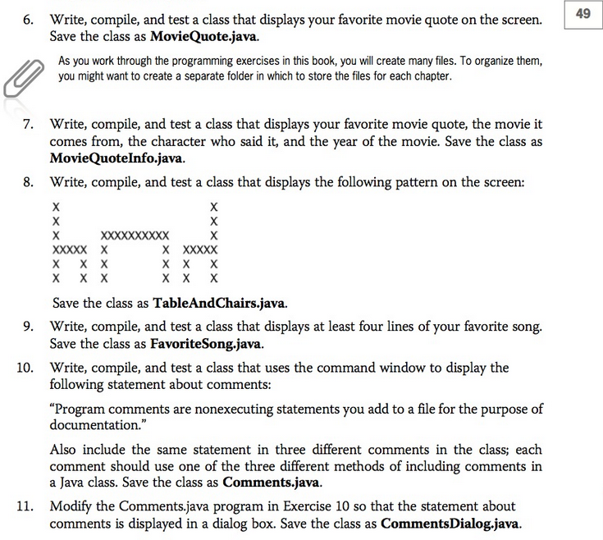

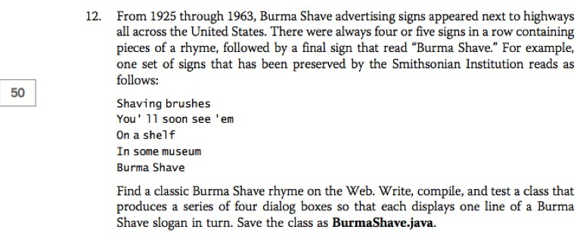

=== END OF THIS PRACTICAL ☺ ===